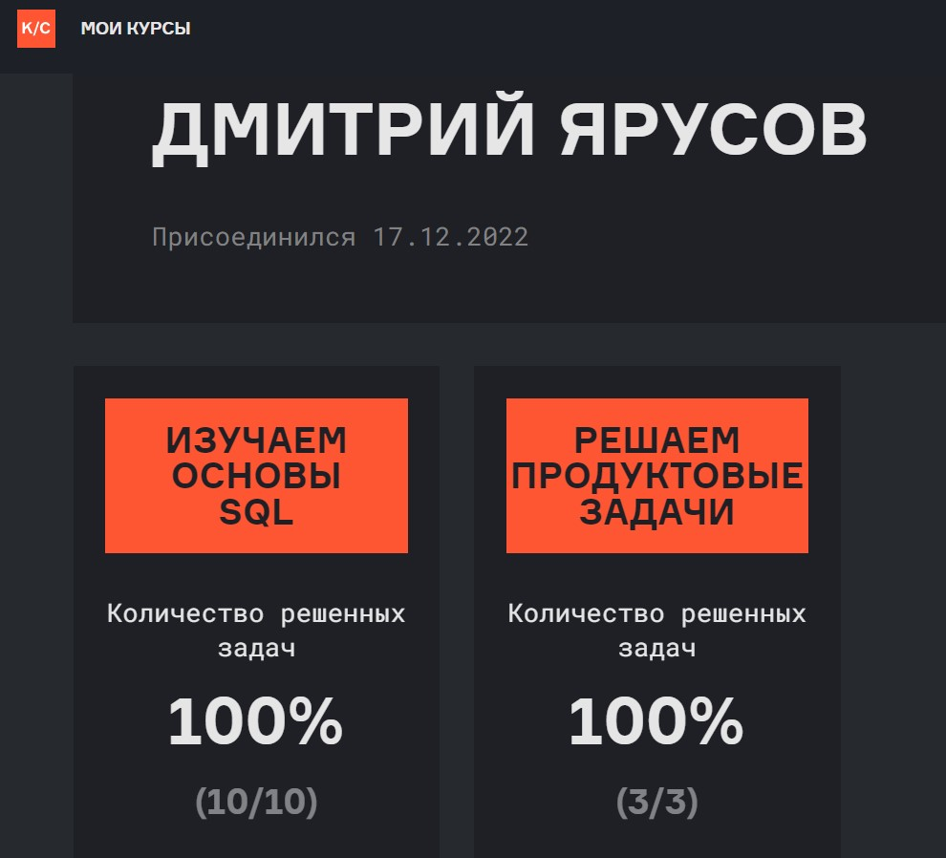https://lab.karpov.courses/live_certificate/261e33ca-eb06-488b-a496-e97dd4d3cdd3/